CO1 AT3
NAME :D. UADY KUMAR
REG NO: 192425307
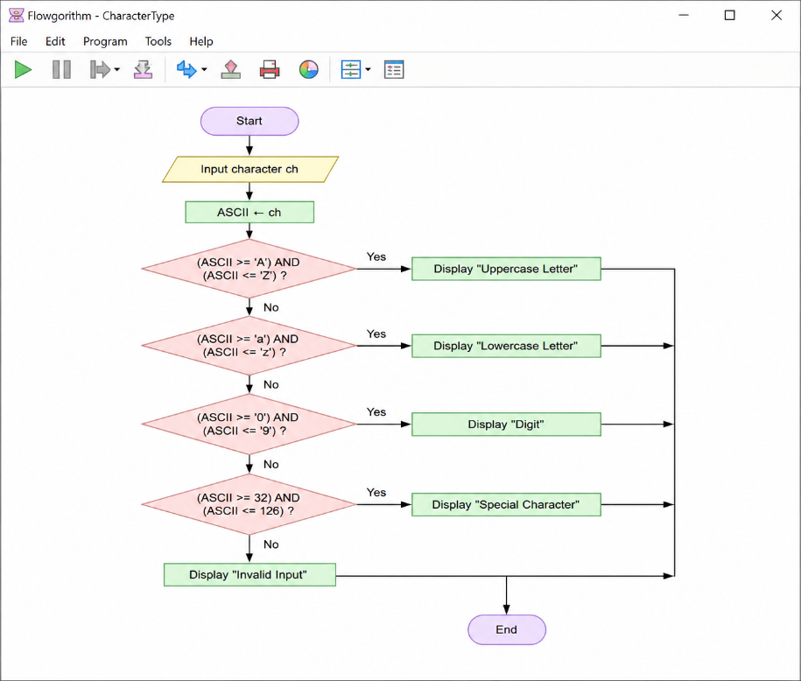
1.Read a character and determine whether it is an uppercase letter, lowercase letter, digit, or special character.

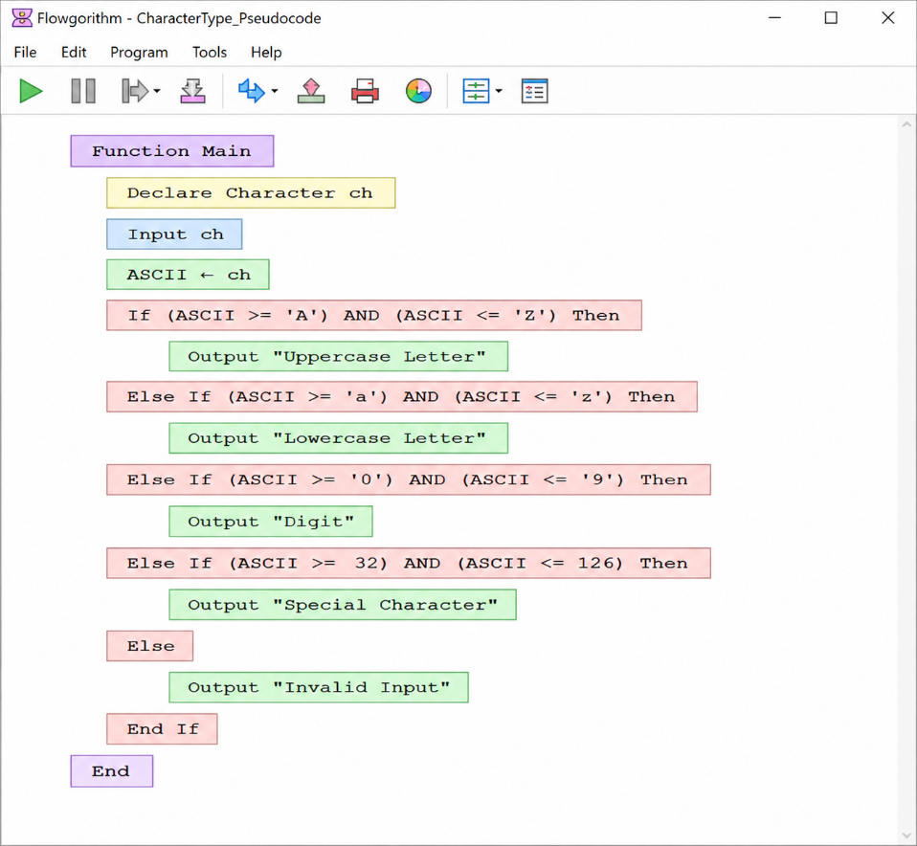

import java.util.Scanner;

public class CharacterType{
public static void main(String[] args){
Scanner sc=new Scanner(System.in);
char ch=sc.next().charAt(0);

if(ch>='A'&&ch<='Z')
System.out.println("Uppercase Letter");
else if(ch>='a'&&ch<='z')
System.out.println("Lowercase Letter");
else if(ch>='0'&&ch<='9')
System.out.println("Digit");
else
System.out.println("Special Character");

sc.close();
}
}

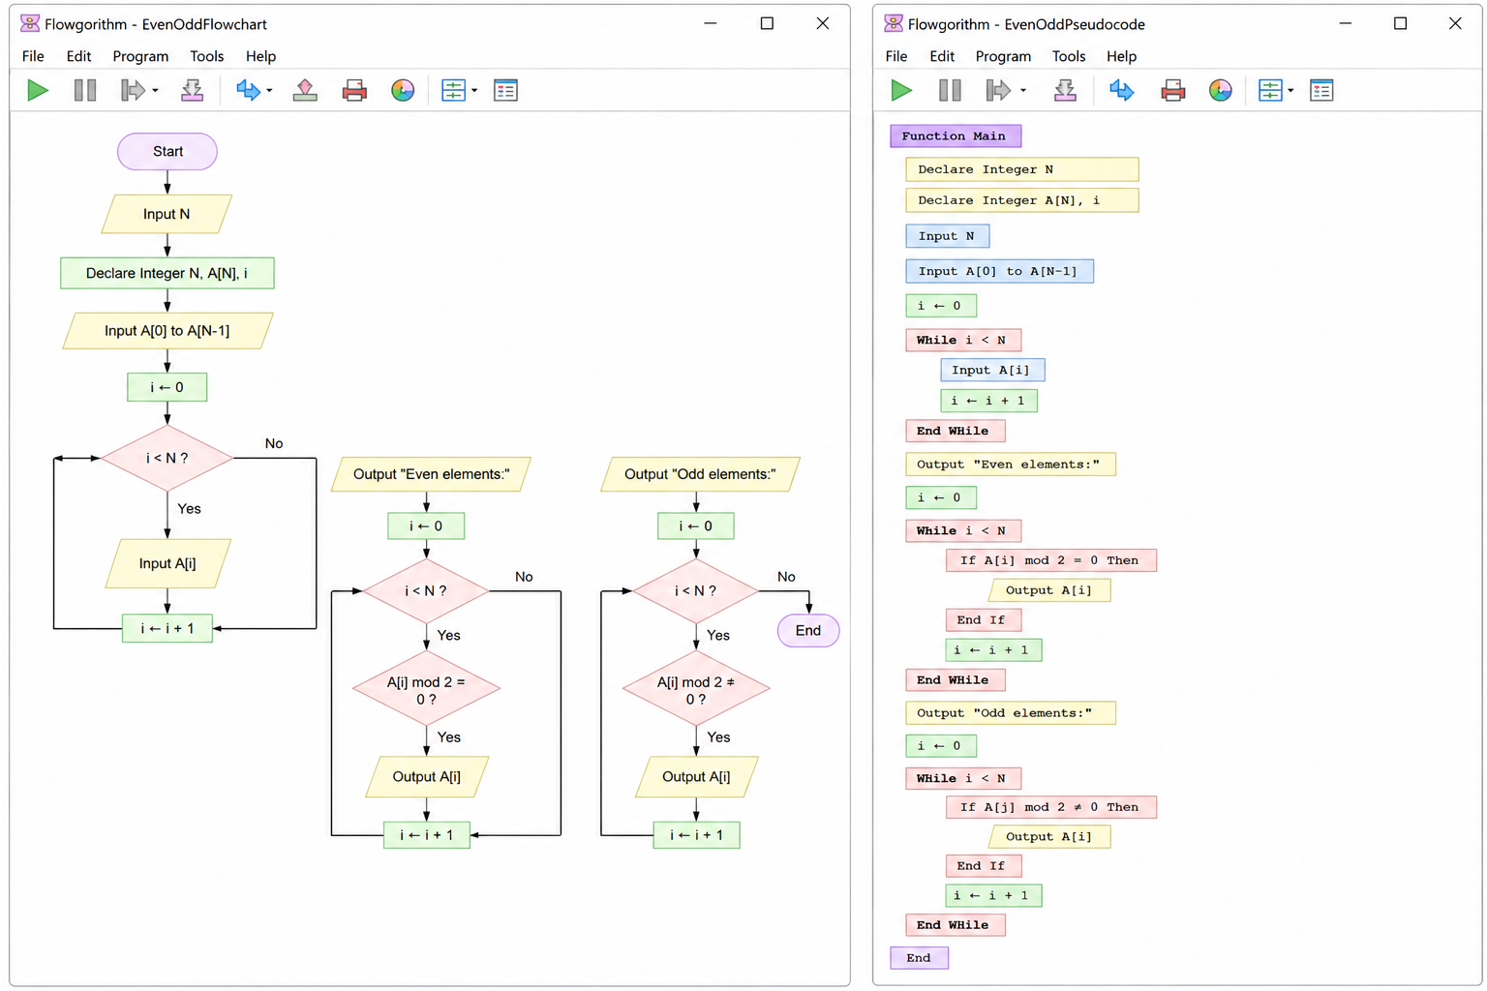
2.Read N integers into an array and display only the even elements followed by only the odd elements.

import java.util.Scanner;
public class EvenOddArray{
public static void main(String[] args){
Scanner sc=new Scanner(System.in);
int n=sc.nextInt();
int[] a=new int[n];

for(int i=0;i<n;i++)
a[i]=sc.nextInt();
for(int i=0;i<n;i++)
if(a[i]%2==0)
System.out.print(a[i]+" ");
System.out.println();
for(int i=0;i<n;i++)
if(a[i]%2!=0)
System.out.print(a[i]+" ");
sc.close();
}
}

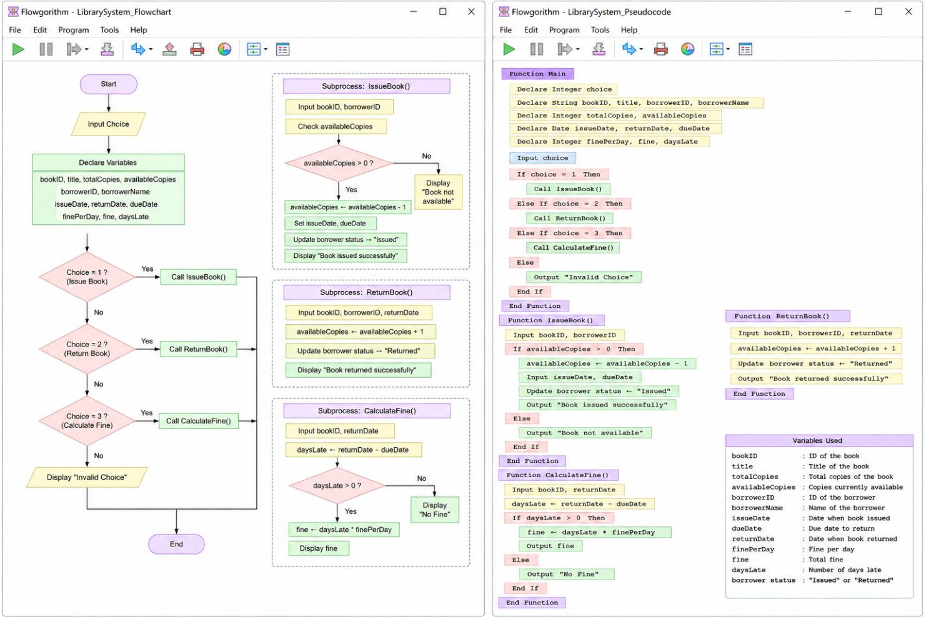
3.Design a library flowchart with functions to issue a book, return book, and calculate fine. Represent book availability and borrower status using variables.

import java.util.Scanner;
public class LibrarySystem{
static boolean available=true;
static boolean borrowed=false;
static void issueBook(){
if(available){
available=false;
borrowed=true;
System.out.println("Book Issued Successfully");
}
else{
System.out.println("Book Not Available");
}
}
static void returnBook(){
if(borrowed){
available=true;
borrowed=false;
System.out.println("Book Returned Successfully");
}
else{
System.out.println("No Book to Return");
}
}
static void calculateFine(int daysLate){
int fine=0;
if(daysLate>0)
fine=daysLate*10;
System.out.println("Fine = "+fine);
}
public static void main(String[] args){
Scanner sc=new Scanner(System.in);
int choice=sc.nextInt();
switch(choice){
case 1:
issueBook();
break;
case 2:
returnBook();
break;
case 3:
int days=sc.nextInt();
calculateFine(days);
break;
default:
System.out.println("Invalid Choice");
}
sc.close();
}
}

